ASSIGNMENT II

M.KEERTHI-920819106024

PYTHON CODE:

import os

import random

for i in range(30,80):

h=random.randint(60,75)

t=random.randint(35,45)

temp=t

humidity=h

print(t)

print(h)

if(humidity>=75 or temp>=40):

print("!!HIGH ALERT!!")

else:

print("low")

PROGRAM:

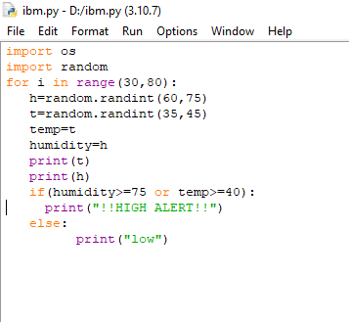

OUTPUT:

